Annex A / Annexe A
Appendix 2 / Appendice 2
Asset Assessment List / Liste d’évaluation des biens

Park/Site  Parc/Site | Asset Name / Nom du bien | Category / Catégorie | Type | Heritage Value /  Valeur patrimoniale | CRV  /  VRA  (K$) | OAC / CGB | Year of Construction / Année de construction | Building Area (m2) / Superficie du batiment (m2)
Banff National Park | Lake Louise Pathways Pipestone #1 | Bridges | Pedestrian Bridges and Structures Class A1 | Not a Cultural Resource/Pas une ressource culturelle | 80 | B
Banff National Park | Lake Louise Pathways Bow River #1 | Bridges | Pedestrian Bridges and Structures Class A1 | Not a Cultural Resource/Pas une ressource culturelle | 162 | C
Banff National Park | Lake Louise Stables- Radio Building/Barn | Buildings | Operation Buildings | Not a Cultural Resource/Pas une ressource culturelle | 246 | B | 1975 | 20
Banff National Park | Lake Louise Stable Barn | Buildings | Operation Buildings | Not a Cultural Resource/Pas une ressource culturelle | 409 | C | 1955 | 53
Banff National Park | Waterfowl Staff Accommodation Laundry | Buildings | Operation Buildings | Not a Cultural Resource/Pas une ressource culturelle | 82 | B | 1960 | 9
Banff National Park | Lake Louise Tenting Kitchen Shelter #1 | Buildings | Public Use Buildings | Not a Cultural Resource/Pas une ressource culturelle | 180 | B | 1965 | 40
Banff National Park | Lake Louise Campground Outdoor Theatre | Buildings | Public Use Buildings | Not a Cultural Resource/Pas une ressource culturelle | 278 | A | 1960 | 38
Banff National Park | Lake Louise Tenting Toilet #8 | Buildings | Public Use Buildings | Not a Cultural Resource/Pas une ressource culturelle | 314 | C | 1986 | 45
Banff National Park | Lake Louise Campground Tenting Shower Building | Buildings | Public Use Buildings | Not a Cultural Resource/Pas une ressource culturelle | 409 | D | 1998 | 114
Banff National Park | Lake Louise Campground Trailer Shower Building | Buildings | Public Use Buildings | Not a Cultural Resource/Pas une ressource culturelle | 491 | B | 1998
Banff National Park | Protection Mountain Kitchen Shelter #4 | Buildings | Public Use Buildings | Not a Cultural Resource/Pas une ressource culturelle | 180 | C | 1958 | 47
Banff National Park | Protection Mountain Toilet #3 | Buildings | Public Use Buildings | Not a Cultural Resource/Pas une ressource culturelle | 270 | C | 1958 | 45
Banff National Park | Waterfowl Campground Kitchen Shelter #4 | Buildings | Public Use Buildings | Not a Cultural Resource/Pas une ressource culturelle | 164 | C | 1960 | 48
Banff National Park | Waterfowl Campground Toilet #2 | Buildings | Public Use Buildings | Not a Cultural Resource/Pas une ressource culturelle | 252 | A | 1955 | 38
Banff National Park | Waterfowl Campground Indoor Theatre | Buildings | Public Use Buildings | Not a Cultural Resource/Pas une ressource culturelle | 531 | C | 1960 | 146
Banff National Park | Lake Louise Information Center | Buildings | Public Use Buildings | Not a Cultural Resource/Pas une ressource culturelle | 7,187 | A | 1987 | 1275
Banff National Park | Protection Mountain Campground Residence | Buildings | Staff Housing | Not a Cultural Resource/Pas une ressource culturelle | 270 | A | 1965 | 94
Banff National Park | Waterfowl Campground Residence #3 | Buildings | Staff Housing | Not a Cultural Resource/Pas une ressource culturelle | 286 | B | 1960 | 90
Banff National Park | Lake Louise Overflow Campground Grounds | Grounds | Camping Grounds | Not a Cultural Resource/Pas une ressource culturelle | 484 | A
Banff National Park | Waterfowl Campground Firewood | Grounds | Camping Grounds | Not a Cultural Resource/Pas une ressource culturelle | 982 | B | 1955
Banff National Park | Protection Mountain Grounds | Grounds | Camping Grounds | Not a Cultural Resource/Pas une ressource culturelle | 1,078 | C | 1958
Banff National Park | Waterfowl Campground Grounds | Grounds | Camping Grounds | Not a Cultural Resource/Pas une ressource culturelle | 1,078 | C
Banff National Park | Lake Louise Campground Tenting Grounds and Trails | Grounds | Day-Use Grounds | Not a Cultural Resource/Pas une ressource culturelle | 4,492 | B | 1985
Banff National Park | Lake Louise Compound Grounds | Grounds | Other Grounds | Not a Cultural Resource/Pas une ressource culturelle | 719 | B | 1985
Banff National Park | Lake Louise Campground Trailer Grounds and Trails | Grounds | Other Grounds | Not a Cultural Resource/Pas une ressource culturelle | 3,593 | B | 1960
Banff National Park | Lake Louise Campground Electrical Distribution | Utilities | Electric Power Systems | Not a Cultural Resource/Pas une ressource culturelle | 968 | A
Banff National Park | Waterfowl Electrical System | Utilities | Electric Power Systems | Not a Cultural Resource/Pas une ressource culturelle | 194 | A
Banff National Park | Well - Protection Mountain Campground | Utilities | Potable Water Systems | Not a Cultural Resource/Pas une ressource culturelle | 32 | B
Banff National Park | Protection Mountain Water System | Utilities | Potable Water Systems | Not a Cultural Resource/Pas une ressource culturelle | 405 | B | 1958
Banff National Park | Waterfowl Campground Water System | Utilities | Potable Water Systems | Not a Cultural Resource/Pas une ressource culturelle | 270 | C | 1960
Banff National Park | New Wells Lake Louise | Utilities | Potable Water Systems | Not a Cultural Resource/Pas une ressource culturelle | 435 | A
Banff National Park | LLYK Telecom | Utilities | Radio Communication Systems | Not a Cultural Resource/Pas une ressource culturelle | 1,963 | B | 1998
Banff National Park | Lake Louise Transfer Station | Utilities | Solid Waste Systems | Not a Cultural Resource/Pas une ressource culturelle | 1,553 | C | 1960
Banff National Park | Lake Louise Campground Lift Station #2 | Utilities | Wastewater Systems | Not a Cultural Resource/Pas une ressource culturelle | 1,102 | B | 1955
Banff National Park | Lake Louise Campground Sewage Collection System | Utilities | Wastewater Systems | Not a Cultural Resource/Pas une ressource culturelle | 1,935 | C
Field Townsite | Field Firehall | Buildings | Operation Buildings | Not a Cultural Resource/Pas une ressource culturelle | 491 | B | 2006 | 278
Field Townsite | Field Information Centre Parking Lot | Grounds | Parking Areas | Not a Cultural Resource/Pas une ressource culturelle | 267 | B | 1986
Field Townsite | Field Treated Water Reservoir | Utilities | Potable Water Systems | Not a Cultural Resource/Pas une ressource culturelle | 1,544 | A
Field Townsite | Field Water Distribution System | Utilities | Potable Water Systems | Not a Cultural Resource/Pas une ressource culturelle | 1,599 | A | 1960
Field Townsite | Field Lift Station #2 - VRC | Utilities | Wastewater Systems | Not a Cultural Resource/Pas une ressource culturelle | 274 | B
Field Townsite | Field Wastewater Plant Overflow Tank | Utilities | Wastewater Systems | Not a Cultural Resource/Pas une ressource culturelle | 329 | B
Field Townsite | Field Wastewater Treatment Plant/Main Lift Station | Utilities | Wastewater Systems | Not a Cultural Resource/Pas une ressource culturelle | 5,297 | B
Lake Louise Townsite | Potable Water Pressure Reducing Station | Utilities | Potable Water Systems | Not a Cultural Resource/Pas une ressource culturelle | 871 | C
Lake Louise Townsite | Old Harry's Hill Pumphouse | Utilities | Potable Water Systems | Not a Cultural Resource/Pas une ressource culturelle | 1,240 | C | 1960
Lake Louise Townsite | Lake Louise Campground Water Distribution System | Utilities | Potable Water Systems | Not a Cultural Resource/Pas une ressource culturelle | 2,903 | C
Linear Mounds National Historic Site of Canada | Fencing at Linear Mounds | Grounds | Other Grounds | Not a Cultural Resource/Pas une ressource culturelle | 10 | A
Linear Mounds National Historic Site of Canada | Linear Mounds Grounds | Grounds | Other Grounds | Not a Cultural Resource/Pas une ressource culturelle | 991 | A
Lower Fort Garry National Historic Site of Canada | Monkmans Creek Pedestrian Bridge | Bridges | Pedestrian Bridges and Structures Class A2 | Not a Cultural Resource/Pas une ressource culturelle | 59 | A
Lower Fort Garry National Historic Site of Canada | Administration Building - Simkin House | Buildings | Administration Buildings | Not a Cultural Resource/Pas une ressource culturelle | 193 | B | 1986 | 191
Lower Fort Garry National Historic Site of Canada | Storage and Mason Shop | Buildings | Operation Buildings | Not a Cultural Resource/Pas une ressource culturelle | 198 | B | 1994 | 90
Lower Fort Garry National Historic Site of Canada | Carpenter Shop | Buildings | Operation Buildings | Not a Cultural Resource/Pas une ressource culturelle | 268 | B | 1971 | 126
Lower Fort Garry National Historic Site of Canada | Water Plant | Buildings | Operation Buildings | Not a Cultural Resource/Pas une ressource culturelle | 429 | C | 1978 | 80
Lower Fort Garry National Historic Site of Canada | Picnic Shelter | Buildings | Public Use Buildings | Not a Cultural Resource/Pas une ressource culturelle | 97 | C | 1995 | 96
Lower Fort Garry National Historic Site of Canada | Blacksmith Shop | Buildings | Public Use Buildings | Not a Cultural Resource/Pas une ressource culturelle | 99 | A | 1850 | 49
Lower Fort Garry National Historic Site of Canada | Doctor's House | Buildings | Public Use Buildings | National Significance/Importance nationale | 101 | A | 1885 | 24
Lower Fort Garry National Historic Site of Canada | Farm Manager House | Buildings | Public Use Buildings | Other Heritage Value/Autres valeurs patrimoniales | 234 | B | 1895 | 135
Lower Fort Garry National Historic Site of Canada | Sout East Bastion - Public Washroom | Buildings | Public Use Buildings | National Significance/Importance nationale | 246 | A | 1831 | 55
Lower Fort Garry National Historic Site of Canada | North East Bastion - Powder Magazine | Buildings | Public Use Buildings | National Significance/Importance nationale | 273 | C | 1847 | 56
Lower Fort Garry National Historic Site of Canada | SW Bastion | Buildings | Public Use Buildings | National Significance/Importance nationale | 292 | A | 1847 | 54
Lower Fort Garry National Historic Site of Canada | Warehouse | Buildings | Public Use Buildings | National Significance/Importance nationale | 648 | A | 1838 | 196
Lower Fort Garry National Historic Site of Canada | Furloft | Buildings | Public Use Buildings | National Significance/Importance nationale | 3,106 | B | 1831 | 195
Lower Fort Garry National Historic Site of Canada | Big House | Buildings | Public Use Buildings | National Significance/Importance nationale | 3,187 | B | 1831 | 396
Lower Fort Garry National Historic Site of Canada | Visitor Reception Centre | Buildings | Public Use Buildings | Not a Cultural Resource/Pas une ressource culturelle | 8,379 | A | 1978 | 1206
Lower Fort Garry National Historic Site of Canada | Day Use Area Grounds | Grounds | Day-Use Grounds | Not a Cultural Resource/Pas une ressource culturelle | 475 | C | 1970
Lower Fort Garry National Historic Site of Canada | Maintenance Compound Grounds | Grounds | Other Grounds | Not a Cultural Resource/Pas une ressource culturelle | 135 | C | 1970
Lower Fort Garry National Historic Site of Canada | Battle of Seven Oaks Grounds | Grounds | Other Grounds | Not a Cultural Resource/Pas une ressource culturelle | 198 | A
Lower Fort Garry National Historic Site of Canada | Monkman's Creek | Grounds | Other Grounds | Not a Cultural Resource/Pas une ressource culturelle | 495 | A
Lower Fort Garry National Historic Site of Canada | Historic Grounds | Grounds | Other Grounds | National Significance/Importance nationale | 1,580 | C | 1970
Lower Fort Garry National Historic Site of Canada | Bell Tower | Heritage Structures and Vessels | Heritage Structures | Not a Cultural Resource/Pas une ressource culturelle | 20 | C
Lower Fort Garry National Historic Site of Canada | North West Bastion - Bake Ovens | Heritage Structures and Vessels | Heritage Structures | National Significance/Importance nationale | 123 | B | 1848
Lower Fort Garry National Historic Site of Canada | Boat Dock / Access | Marine Assets | Wharves and Docks | Not a Cultural Resource/Pas une ressource culturelle | 295 | C | 1998
St. Andrew's Rectory National Historic Site of Canada | St. Andrews Rectory | Buildings | Public Use Buildings | National Significance/Importance nationale | 1,166 | B | 1854 | 199
St. Andrew's Rectory National Historic Site of Canada | St Andrews Rectory Historic Grounds | Grounds | Other Grounds | Not a Cultural Resource/Pas une ressource culturelle | 386 | B | 1851
The Forks National Historic Site of Canada | VHAP Maintenance Building | Buildings | Operation Buildings | Not a Cultural Resource/Pas une ressource culturelle | 45 | A
The Forks National Historic Site of Canada | Orientation Node | Buildings | Public Use Buildings | Not a Cultural Resource/Pas une ressource culturelle | 404 | B | 1989 | 119
The Forks National Historic Site of Canada | Amphitheatre | Grounds | Day-Use Grounds | Not a Cultural Resource/Pas une ressource culturelle | 1,818 | B | 1989
The Forks National Historic Site of Canada | Day Use Area | Grounds | Day-Use Grounds | Not a Cultural Resource/Pas une ressource culturelle | 2,183 | C | 1989
The Forks National Historic Site of Canada | Riparian Forest | Grounds | Other Grounds | Not a Cultural Resource/Pas une ressource culturelle | 991 | C
The Forks National Historic Site of Canada | River Walkway/Vehicle Ramp | Grounds | Trails | Not a Cultural Resource/Pas une ressource culturelle | 4,953 | C
The Forks National Historic Site of Canada | Major Boat Dock | Marine Assets | Wharves and Docks | Not a Cultural Resource/Pas une ressource culturelle | 1,212 | A | 1989
Trent-Severn Waterway National Historic Site of Canada | Foot Bridge - Sill's Island | Bridges | Pedestrian Bridges and Structures Class A2 | Not a Cultural Resource/Pas une ressource culturelle | 368 | C | 1950
Trent-Severn Waterway National Historic Site of Canada | By-pass Culvert - Healey Falls Flight Locks # 16/17 | Bridges | Vehicular Bridges and Culverts | Not a Cultural Resource/Pas une ressource culturelle | 955 | B
Trent-Severn Waterway National Historic Site of Canada | Culvert - Frankford Lock # 6 | Bridges | Vehicular Bridges and Culverts | Not a Cultural Resource/Pas une ressource culturelle | 530 | B
Trent-Severn Waterway National Historic Site of Canada | Swing Bridge # 15 - Healey Falls | Bridges | Vehicular Bridges and Culverts | Other Heritage Value/Autres valeurs patrimoniales | 3,778 | B | 1915
Trent-Severn Waterway National Historic Site of Canada | Bridge Control Building - Bolsover Bridge # 43 | Buildings | Operation Buildings | Not a Cultural Resource/Pas une ressource culturelle | 106 | C | 1964 | 18
Trent-Severn Waterway National Historic Site of Canada | Bridge Control Building - Carrying Place Bridge | Buildings | Operation Buildings | Not a Cultural Resource/Pas une ressource culturelle | 371 | B | 1965 | 3
Trent-Severn Waterway National Historic Site of Canada | Upstream Breakwater - Dam # 6 Frankford | Marine Assets | Breakwaters | Not a Cultural Resource/Pas une ressource culturelle | 6,364 | A
Trent-Severn Waterway National Historic Site of Canada | Dam # 2 - Sydney Lock # 2 | Marine Assets | Dams | Other Heritage Value/Autres valeurs patrimoniales | 37,123 | B | 1992
Trent-Severn Waterway National Historic Site of Canada | Dam # 5 - Trent Lock # 5 | Marine Assets | Dams | Other Heritage Value/Autres valeurs patrimoniales | 29,698 | C | 1993
Trent-Severn Waterway National Historic Site of Canada | Dam # 14 - Healey Falls | Marine Assets | Dams | Other Heritage Value/Autres valeurs patrimoniales | 37,123 | B
Trent-Severn Waterway National Historic Site of Canada | Dam # 15 - Hastings | Marine Assets | Dams | Other Heritage Value/Autres valeurs patrimoniales | 37,123 | C | 1968
Trent-Severn Waterway National Historic Site of Canada | Dam at Lock # 26 - Lakefield | Marine Assets | Dams | Not a Cultural Resource/Pas une ressource culturelle | 9,546 | B | 1987
Trent-Severn Waterway National Historic Site of Canada | Dam at Lock # 27 - Youngs Point | Marine Assets | Dams | Not a Cultural Resource/Pas une ressource culturelle | 23,334 | B
Trent-Severn Waterway National Historic Site of Canada | Dam at Lock # 31 - Buckhorn | Marine Assets | Dams | Not a Cultural Resource/Pas une ressource culturelle | 33,941 | A | 1978
Trent-Severn Waterway National Historic Site of Canada | Upstream Left Entrance Wall and Embankment - Bobcaygeon Dam | Marine Assets | Dams | Not a Cultural Resource/Pas une ressource culturelle | 1,167 | B
Trent-Severn Waterway National Historic Site of Canada | Upstream Wall and Embankment - Buckhorn Dam | Marine Assets | Dams | Not a Cultural Resource/Pas une ressource culturelle | 18,031 | C
Trent-Severn Waterway National Historic Site of Canada | Dam at Lock # 33 Lindsay | Marine Assets | Dams | Other Heritage Value/Autres valeurs patrimoniales | 10,607 | B
Trent-Severn Waterway National Historic Site of Canada | Dam at Lock # 32 - Bobcaygeon | Marine Assets | Dams | Other Heritage Value/Autres valeurs patrimoniales | 15,910 | B
Trent-Severn Waterway National Historic Site of Canada | Rosedale Lock # 35 | Marine Assets | Locks | Not a Cultural Resource/Pas une ressource culturelle | 11,667 | C
Trent-Severn Waterway National Historic Site of Canada | Batawa Lock # 4 | Marine Assets | Locks | Other Heritage Value/Autres valeurs patrimoniales | 12,728 | B
Trent-Severn Waterway National Historic Site of Canada | Frankford Lock # 6 | Marine Assets | Locks | Other Heritage Value/Autres valeurs patrimoniales | 12,728 | C
Trent-Severn Waterway National Historic Site of Canada | Trent Lock # 5 | Marine Assets | Locks | Other Heritage Value/Autres valeurs patrimoniales | 12,728 | B
Trent-Severn Waterway National Historic Site of Canada | Hastings Lock # 18 | Marine Assets | Locks | Other Heritage Value/Autres valeurs patrimoniales | 12,728 | B
Trent-Severn Waterway National Historic Site of Canada | Youngs Point Lock # 27 | Marine Assets | Locks | Not a Cultural Resource/Pas une ressource culturelle | 12,728 | B
Trent-Severn Waterway National Historic Site of Canada | Bobcaygeon Lock # 32 | Marine Assets | Locks | Not a Cultural Resource/Pas une ressource culturelle | 12,728 | B
Trent-Severn Waterway National Historic Site of Canada | Lindsay Lock # 33 | Marine Assets | Locks | Other Heritage Value/Autres valeurs patrimoniales | 12,728 | A
Trent-Severn Waterway National Historic Site of Canada | Bolsover Lock # 37 | Marine Assets | Locks | National Significance/Importance nationale | 14,849 | C
Trent-Severn Waterway National Historic Site of Canada | Downstream Left Entrance Wall - Lindsay Lock # 33 | Marine Assets | Marine Walls | Not a Cultural Resource/Pas une ressource culturelle | 318 | B
Trent-Severn Waterway National Historic Site of Canada | Upstream Right Entrance Wall - Lindsay Lock # 33 | Marine Assets | Marine Walls | Not a Cultural Resource/Pas une ressource culturelle | 445 | B
Trent-Severn Waterway National Historic Site of Canada | Upstream Left Entrance Wall - Hastings Lock # 18 | Marine Assets | Marine Walls | Not a Cultural Resource/Pas une ressource culturelle | 636 | A
Trent-Severn Waterway National Historic Site of Canada | Upstream Canal Walls - Batawa Lock # 4 | Marine Assets | Marine Walls | Not a Cultural Resource/Pas une ressource culturelle | 795 | A
Trent-Severn Waterway National Historic Site of Canada | Upstream Entrance Walls - Trent Lock # 5 | Marine Assets | Marine Walls | Not a Cultural Resource/Pas une ressource culturelle | 795 | A
Trent-Severn Waterway National Historic Site of Canada | Downstream Entrance Walls - Frankford Lock # 6 | Marine Assets | Marine Walls | Not a Cultural Resource/Pas une ressource culturelle | 795 | A
Trent-Severn Waterway National Historic Site of Canada | Downstream Entrance Walls - Trent Lock # 5 | Marine Assets | Marine Walls | Not a Cultural Resource/Pas une ressource culturelle | 795 | B
Trent-Severn Waterway National Historic Site of Canada | Downstream Walls - Dam at Lock # 27 Youngs Point | Marine Assets | Marine Walls | Not a Cultural Resource/Pas une ressource culturelle | 849 | B
Trent-Severn Waterway National Historic Site of Canada | Downstream Right Entrance Wall - Lindsay Lock # 33 | Marine Assets | Marine Walls | Not a Cultural Resource/Pas une ressource culturelle | 849 | B
Trent-Severn Waterway National Historic Site of Canada | Downstream Left Entrance Wall - Rosedale Lock # 35 | Marine Assets | Marine Walls | Not a Cultural Resource/Pas une ressource culturelle | 912 | B
Trent-Severn Waterway National Historic Site of Canada | Downstream Right Entrance Wall - Rosedale Lock # 35 | Marine Assets | Marine Walls | Not a Cultural Resource/Pas une ressource culturelle | 955 | B
Trent-Severn Waterway National Historic Site of Canada | Upstream Right Entrance Wall - Rosedale Lock # 35 | Marine Assets | Marine Walls | Not a Cultural Resource/Pas une ressource culturelle | 955 | B
Trent-Severn Waterway National Historic Site of Canada | Upstream Canal Wall - Hastings # 18 | Marine Assets | Marine Walls | Not a Cultural Resource/Pas une ressource culturelle | 955 | B
Trent-Severn Waterway National Historic Site of Canada | Upstream Left Entrance Wall - Rosedale Lock # 35 | Marine Assets | Marine Walls | Not a Cultural Resource/Pas une ressource culturelle | 1,050 | B
Trent-Severn Waterway National Historic Site of Canada | Upstream Entrance Walls - Frankford Lock # 6 | Marine Assets | Marine Walls | Not a Cultural Resource/Pas une ressource culturelle | 1,273 | A
Trent-Severn Waterway National Historic Site of Canada | Upstream Right Entrance Wall - Hastings Lock # 18 | Marine Assets | Marine Walls | Not a Cultural Resource/Pas une ressource culturelle | 1,273 | A
Trent-Severn Waterway National Historic Site of Canada | Downstream Entrance Walls - Batawa Lock # 4 | Marine Assets | Marine Walls | Not a Cultural Resource/Pas une ressource culturelle | 1,591 | B
Trent-Severn Waterway National Historic Site of Canada | Downtream Entrance Walls - Hastings Lock # 18 | Marine Assets | Marine Walls | Not a Cultural Resource/Pas une ressource culturelle | 1,803 | B
Trent-Severn Waterway National Historic Site of Canada | Downstream Entrance Walls - Youngs Point Lock # 27 | Marine Assets | Marine Walls | Not a Cultural Resource/Pas une ressource culturelle | 2,068 | B
Trent-Severn Waterway National Historic Site of Canada | Downstream Entrance Walls - Bolsover Lock # 37 | Marine Assets | Marine Walls | Not a Cultural Resource/Pas une ressource culturelle | 2,121 | C
Trent-Severn Waterway National Historic Site of Canada | Upstream Entrance Walls - Bobcaygeon Lock # 32 | Marine Assets | Marine Walls | Not a Cultural Resource/Pas une ressource culturelle | 2,546 | B
Trent-Severn Waterway National Historic Site of Canada | Downstream Entrance Walls - Bobcaygeon Lock # 32 | Marine Assets | Marine Walls | Not a Cultural Resource/Pas une ressource culturelle | 3,818 | C
Trent-Severn Waterway National Historic Site of Canada | Downstream Wharf - Buckhorn Lock # 31 | Marine Assets | Wharves and Docks | Not a Cultural Resource/Pas une ressource culturelle | 85 | A
Trent-Severn Waterway National Historic Site of Canada | Upstream Left Wharf - Lakefield Lock # 26 | Marine Assets | Wharves and Docks | Not a Cultural Resource/Pas une ressource culturelle | 1,909 | A
Rideau Canal National Historic Site of Canada | Fixed Bridge - Long Island Dam | Bridges | Vehicular Bridges and Culverts | Not a Cultural Resource/Pas une ressource culturelle | 956 | A | 1978
Rideau Canal National Historic Site of Canada | Swing Bridge - Long Island | Bridges | Vehicular Bridges and Culverts | Other Heritage Value/Autres valeurs patrimoniales | 3,861 | B | 1921
Rideau Canal National Historic Site of Canada | Swing Bridge - Brass Point | Bridges | Vehicular Bridges and Culverts | Not a Cultural Resource/Pas une ressource culturelle | 4,302 | C | 1978
Rideau Canal National Historic Site of Canada | Fixed Bridge - Brass Point | Bridges | Vehicular Bridges and Culverts | Not a Cultural Resource/Pas une ressource culturelle | 6,916 | B | 1978
Rideau Canal National Historic Site of Canada | Woods Mill - Rideau Headquarters Smiths Falls | Buildings | Administration Buildings | Other Heritage Value/Autres valeurs patrimoniales | 15,218 | B | 1852 | 1579
Rideau Canal National Historic Site of Canada | Quonset Small - Smiths Falls Compound | Buildings | Operation Buildings | Not a Cultural Resource/Pas une ressource culturelle | 106 | B | 1997 | 116
Rideau Canal National Historic Site of Canada | Quonset Large- Smiths Falls Compound | Buildings | Operation Buildings | Not a Cultural Resource/Pas une ressource culturelle | 127 | B | 1997 | 231
Rideau Canal National Historic Site of Canada | Garage - Smiths Falls Compound | Buildings | Operation Buildings | Not a Cultural Resource/Pas une ressource culturelle | 371 | B | 1940 | 532
Rideau Canal National Historic Site of Canada | Gate Shop - Smiths Falls Compound | Buildings | Operation Buildings | Not a Cultural Resource/Pas une ressource culturelle | 371 | B | 1971 | 484
Rideau Canal National Historic Site of Canada | Machine Shop - Smiths Falls Compound | Buildings | Operation Buildings | Not a Cultural Resource/Pas une ressource culturelle | 371 | B | 1964 | 348
Rideau Canal National Historic Site of Canada | Bridge Control Building - Brass Point Bridge | Buildings | Public Use Buildings | Not a Cultural Resource/Pas une ressource culturelle | 120 | B | 1979 | 29
Rideau Canal National Historic Site of Canada | Grounds - Brass Point Bridge | Grounds | Day-Use Grounds | Not a Cultural Resource/Pas une ressource culturelle | 12 | A | 1979
Rideau Canal National Historic Site of Canada | Boat Launch - Long Island | Marine Assets | Boat Launches | Not a Cultural Resource/Pas une ressource culturelle | 1,020 | C | 1980
Rideau Canal National Historic Site of Canada | Waste Weir - Hartwells | Marine Assets | Dams | Not a Cultural Resource/Pas une ressource culturelle | 239 | C | 1904
Rideau Canal National Historic Site of Canada | Tunnel (Waste Weir) - Hartwells | Marine Assets | Dams | Not a Cultural Resource/Pas une ressource culturelle | 727 | A | 1904
Rideau Canal National Historic Site of Canada | Arch Dam - Long Island | Marine Assets | Dams | National Significance/Importance nationale | 10,407 | B | 1830
Rideau Canal National Historic Site of Canada | Weir - Long Island | Marine Assets | Dams | Not a Cultural Resource/Pas une ressource culturelle | 12,040 | B | 1978
Rideau Canal National Historic Site of Canada | Lock # 16 - Long Island | Marine Assets | Locks | National Significance/Importance nationale | 7,978 | B | 1830
Rideau Canal National Historic Site of Canada | Lock # 29A - Combined (Hydraulic ) | Marine Assets | Locks | Not a Cultural Resource/Pas une ressource culturelle | 17,951 | C | 1972
Rideau Canal National Historic Site of Canada | Canal Wall - Brass Point | Marine Assets | Marine Walls | Not a Cultural Resource/Pas une ressource culturelle | 201 | B | 1979
Rideau Canal National Historic Site of Canada | Canal Walls - Hogs Back to Hartwells East | Marine Assets | Marine Walls | Not a Cultural Resource/Pas une ressource culturelle | 15,352 | C | 1930
Rideau Canal National Historic Site of Canada | Water Gauge - Brass Point Bridge | Marine Assets | Other Marine Structures | Not a Cultural Resource/Pas une ressource culturelle | 21 | B | 1993
Rideau Canal National Historic Site of Canada | Whitehorse Pier (dam) - Long Island | Marine Assets | Other Marine Structures | Not a Cultural Resource/Pas une ressource culturelle | 1,380 | A | 1920
Rideau Canal National Historic Site of Canada | Left Upper Wharf - Long Island | Marine Assets | Wharves and Docks | Not a Cultural Resource/Pas une ressource culturelle | 1,033 | B | 1989
Rideau Canal National Historic Site of Canada | Right Lower Wharf - Long Island | Marine Assets | Wharves and Docks | Not a Cultural Resource/Pas une ressource culturelle | 1,828 | B | 1981
Chambly Canal National Historic Site of Canada | Entrepôt de signalisation - Ateliers | Buildings | Operation Buildings | Not a Cultural Resource/Pas une ressource culturelle | 42 | A | 1963 | 23
Chambly Canal National Historic Site of Canada | Entrepôt à bois - Ateliers | Buildings | Operation Buildings | Not a Cultural Resource/Pas une ressource culturelle | 60 | C | 1994 | 75
Chambly Canal National Historic Site of Canada | Atelier de menuiserie | Buildings | Operation Buildings | National Significance/Importance nationale | 1,845 | B | 1883 | 1061
Chambly Canal National Historic Site of Canada | Entrepôt d'acier - Ateliers | Buildings | Operation Buildings | Not a Cultural Resource/Pas une ressource culturelle | 20 | A | 1994 | 43
Chambly Canal National Historic Site of Canada | Entrepôt d'enseignes - Ateliers | Buildings | Operation Buildings | Not a Cultural Resource/Pas une ressource culturelle | 27 | A | 1982 | 62
Chambly Canal National Historic Site of Canada | Bureau et atelier d'usinage | Buildings | Operation Buildings | Not a Cultural Resource/Pas une ressource culturelle | 2,767 | B | 1970 | 1300
Chambly Canal National Historic Site of Canada | Entrepôt - Ateliers | Buildings | Operation Buildings | Not a Cultural Resource/Pas une ressource culturelle | 38 | C | 1963 | 53
Chambly Canal National Historic Site of Canada | Entrepôt matières inflammables - Ateliers | Buildings | Operation Buildings | Not a Cultural Resource/Pas une ressource culturelle | 51 | A | 1965 | 38
Chambly Canal National Historic Site of Canada | Entrepôt pour pièces - Ateliers | Buildings | Operation Buildings | National Significance/Importance nationale | 355 | A | 1911 | 357
Chambly Canal National Historic Site of Canada | Garage - Ateliers | Buildings | Operation Buildings | Not a Cultural Resource/Pas une ressource culturelle | 825 | A | 1992 | 427
Chambly Canal National Historic Site of Canada | Remise - Ateliers | Buildings | Operation Buildings | Not a Cultural Resource/Pas une ressource culturelle | 10 | A | 1973 | 6
Chambly Canal National Historic Site of Canada | Pavillon d'accueil - Ateliers | Buildings | Public Use Buildings | Not a Cultural Resource/Pas une ressource culturelle | 172 | B | 1966 | 150
Chambly Canal National Historic Site of Canada | Cour d'entreposage - Ateliers | Grounds | Other Grounds | Not a Cultural Resource/Pas une ressource culturelle | 126 | B | 1960
Chambly Canal National Historic Site of Canada | Cour et stationnement - Ateliers | Grounds | Parking Areas | Not a Cultural Resource/Pas une ressource culturelle | 520 | C | 1883
Chambly Canal National Historic Site of Canada | Rue Mignault | Roadways | Class 4 - Access Roads to Visitor Facilities | Not a Cultural Resource/Pas une ressource culturelle | 225 | B
Lachine Canal National Historic Site of Canada | Atelier # 1 - Principal | Buildings | Operation Buildings | Not a Cultural Resource/Pas une ressource culturelle | 2,400 | B | 1909 | 804
Lachine Canal National Historic Site of Canada | Atelier # 2 - Entreposage | Buildings | Operation Buildings | Not a Cultural Resource/Pas une ressource culturelle | 1,800 | B | 1925 | 417
Lachine Canal National Historic Site of Canada | Atelier # 3 - Forgerons | Buildings | Operation Buildings | Not a Cultural Resource/Pas une ressource culturelle | 1,000 | D | 1930 | 137
Lachine Canal National Historic Site of Canada | Vieux Canal | Heritage Structures and Vessels | Heritage Structures | Not a Cultural Resource/Pas une ressource culturelle | 20,000 | C | 1875
Lachine Canal National Historic Site of Canada | Déversoir # 1 | Marine Assets | Dams | Not a Cultural Resource/Pas une ressource culturelle | 5,000 | D
Lachine Canal National Historic Site of Canada | Déversoir Mills | Marine Assets | Dams | Not a Cultural Resource/Pas une ressource culturelle | 10,000 | B | 1958
Lachine Canal National Historic Site of Canada | Déversoir # 2 | Marine Assets | Dams | Not a Cultural Resource/Pas une ressource culturelle | 5,000 | D
Lachine Canal National Historic Site of Canada | CL-B4-11 Digue en terre Notre-Dame | Marine Assets | Dams | Not a Cultural Resource/Pas une ressource culturelle | 73,987 | B
Lachine Canal National Historic Site of Canada | CL-B3-08 Digue en terre (lampadaires D14 à E8) | Marine Assets | Dams | Not a Cultural Resource/Pas une ressource culturelle | 2,852 | B
Lachine Canal National Historic Site of Canada | CL-B3-10 Digue en terre (lampadaires E14 et E19) | Marine Assets | Dams | Not a Cultural Resource/Pas une ressource culturelle | 2,170 | B
Lachine Canal National Historic Site of Canada | CL-B3-12 Digue en terre (lampadaires E25 à F4) | Marine Assets | Dams | Not a Cultural Resource/Pas une ressource culturelle | 9,907 | B
Lachine Canal National Historic Site of Canada | CL-B3-07 Digue en terre (lampadaires G8 à G13) | Marine Assets | Dams | Not a Cultural Resource/Pas une ressource culturelle | 2,232 | B
Lachine Canal National Historic Site of Canada | Écluse # 2 | Marine Assets | Locks | Not a Cultural Resource/Pas une ressource culturelle | 15,000 | C
Lachine Canal National Historic Site of Canada | Écluse # 1 | Marine Assets | Locks | Not a Cultural Resource/Pas une ressource culturelle | 15,000 | C
Fort Beauséjour-Fort Cumberland National Historic Site of Canada | Large Pavilion | Buildings | Public Use Buildings | Other Heritage Value/Autres valeurs patrimoniales | 82 | C | 1920 | 68
Fort Beauséjour-Fort Cumberland National Historic Site of Canada | Visitor Reception Centre /Museum | Buildings | Public Use Buildings | Other Heritage Value/Autres valeurs patrimoniales | 3,073 | B | 1940 | 490
Fort Beauséjour-Fort Cumberland National Historic Site of Canada | Casemates | Fortifications | Casemates | Not a Cultural Resource/Pas une ressource culturelle | 1,844 | B | 1700
Fort Beauséjour-Fort Cumberland National Historic Site of Canada | Curtain Walls and Ruins | Fortifications | Fortification Walls | National Significance/Importance nationale | 3,073 | C | 1700
Fort Beauséjour-Fort Cumberland National Historic Site of Canada | Fortification Grounds | Grounds | Day-Use Grounds | Not a Cultural Resource/Pas une ressource culturelle | 256 | C | 1700
Fort Beauséjour-Fort Cumberland National Historic Site of Canada | Fort Beausejour-Fort Cumberland HSMBC # 1146 a and b | Grounds | Monuments and Plaques | Other Heritage Value/Autres valeurs patrimoniales | 10 | B | 1923
Grand-Pré National Historic Site of Canada | Visitor Reception Centre | Buildings | Public Use Buildings | Not a Cultural Resource/Pas une ressource culturelle | 2,766 | A | 2004 | 1424
Grand-Pré National Historic Site of Canada | Memorial Church | Buildings | Public Use Buildings | National Significance/Importance nationale | 3,073 | C | 1922 | 145
Grand-Pré National Historic Site of Canada | Grounds | Grounds | Day-Use Grounds | National Significance/Importance nationale | 4,917 | A | 1920
Grand-Pré National Historic Site of Canada | Church Potable Water System | Utilities | Potable Water Systems | Not a Cultural Resource/Pas une ressource culturelle | 46 | A | 2015
Kouchibouguac National Park of Canada | Interpretation Field Office | Buildings | Operation Buildings | Not a Cultural Resource/Pas une ressource culturelle | 72 | B | 1972 | 53
Kouchibouguac National Park of Canada | Resource Conservation Building | Buildings | Operation Buildings | Not a Cultural Resource/Pas une ressource culturelle | 72 | B | 1972 | 46
Kouchibouguac National Park of Canada | Visitor Services Building | Buildings | Operation Buildings | Not a Cultural Resource/Pas une ressource culturelle | 72 | B | 1972 | 38
Kouchibouguac National Park of Canada | Storage Building | Buildings | Operation Buildings | Not a Cultural Resource/Pas une ressource culturelle | 179 | C | 1981 | 335
Kouchibouguac National Park of Canada | Works Building | Buildings | Operation Buildings | Not a Cultural Resource/Pas une ressource culturelle | 1,639 | B | 1975
Kouchibouguac National Park of Canada | Kiosk South Kouchibouguac Campground | Buildings | Public Use Buildings | Not a Cultural Resource/Pas une ressource culturelle | 67 | B | 1975 | 22
Kouchibouguac National Park of Canada | Bon Accueil Building | Buildings | Public Use Buildings | Not a Cultural Resource/Pas une ressource culturelle | 236 | A | 2013
Kouchibouguac National Park of Canada | Ryans Boat House | Buildings | Public Use Buildings | Not a Cultural Resource/Pas une ressource culturelle | 179 | C | 1978 | 66
Kouchibouguac National Park of Canada | Ryans Rental Concession Building | Buildings | Public Use Buildings | Not a Cultural Resource/Pas une ressource culturelle | 359 | B | 1975 | 101
Kouchibouguac National Park of Canada | Pijeboogwek Building | Buildings | Public Use Buildings | Not a Cultural Resource/Pas une ressource culturelle | 215 | A | 1983 | 111
Kouchibouguac National Park of Canada | Service Building A | Buildings | Public Use Buildings | Not a Cultural Resource/Pas une ressource culturelle | 328 | A | 1974 | 72
Kouchibouguac National Park of Canada | Administration and Visitor Reception Centre Building | Buildings | Public Use Buildings | Not a Cultural Resource/Pas une ressource culturelle | 4,302 | B | 1984 | 400
Kouchibouguac National Park of Canada | Grounds South Kouchibouguac Campground | Grounds | Camping Grounds | Not a Cultural Resource/Pas une ressource culturelle | 3,585 | A | 1975
Kouchibouguac National Park of Canada | Entrance Kiosk Grounds | Grounds | Day-Use Grounds | Not a Cultural Resource/Pas une ressource culturelle | 56 | A | 1978
Kouchibouguac National Park of Canada | Administration/Visitor Reception Centre Grounds | Grounds | Day-Use Grounds | Not a Cultural Resource/Pas une ressource culturelle | 82 | B | 1984
Kouchibouguac National Park of Canada | Parking Lot Entrance Kiosk | Grounds | Parking Areas | Not a Cultural Resource/Pas une ressource culturelle | 26 | A | 1988
Kouchibouguac National Park of Canada | Visitor Parking-South Kouchibouguac Campground | Grounds | Parking Areas | Not a Cultural Resource/Pas une ressource culturelle | 61 | A | 1979
Kouchibouguac National Park of Canada | Ryans Parking | Grounds | Parking Areas | Not a Cultural Resource/Pas une ressource culturelle | 333 | B | 1975
Kouchibouguac National Park of Canada | Ryans Power Distribution Line | Utilities | Electric Power Systems | Not a Cultural Resource/Pas une ressource culturelle | 215 | B | 1974
Kouchibouguac National Park of Canada | Power Line to Administration Building | Utilities | Electric Power Systems | Not a Cultural Resource/Pas une ressource culturelle | 205 | A | 1973
Kouchibouguac National Park of Canada | Power Distribution South Kouchibouguac Campground | Utilities | Electric Power Systems | Not a Cultural Resource/Pas une ressource culturelle | 1,844 | A | 2014
Kouchibouguac National Park of Canada | Potable Water System Building E and F | Utilities | Potable Water Systems | Not a Cultural Resource/Pas une ressource culturelle | 236 | A | 2015
Kouchibouguac National Park of Canada | Storm Sewer loop #3 South Kouchibouguac Campground Site #81 | Utilities | Wastewater Systems | Not a Cultural Resource/Pas une ressource culturelle | 41 | A | 1978
Kouchibouguac National Park of Canada | Sewage Collector System South Kouchibouguac Campground | Utilities | Wastewater Systems | Not a Cultural Resource/Pas une ressource culturelle | 666 | A | 2014
Georges Island National Historic Site of Canada | Guardroom Jail | Buildings | Public Use Buildings | National Significance/Importance nationale | 615 | B | 1866
Georges Island National Historic Site of Canada | Married Officer's Quarters | Buildings | Public Use Buildings | National Significance/Importance nationale | 256 | B | 1901
Georges Island National Historic Site of Canada | Artillery Store | Buildings | Public Use Buildings | National Significance/Importance nationale | 154 | B | 1877
Georges Island National Historic Site of Canada | Main Magazine and Tunnel Complex | Fortifications | Bastions | National Significance/Importance nationale | 20,486 | B | 1867
Georges Island National Historic Site of Canada | South Escarp | Fortifications | Bastions | National Significance/Importance nationale | 10,243 | B | 1867
Georges Island National Historic Site of Canada | South Counterscarp | Fortifications | Bastions | National Significance/Importance nationale | 4,097 | B | 1871
Georges Island National Historic Site of Canada | Quick Fire # 2 | Fortifications | Bastions | National Significance/Importance nationale | 615 | C | 1904
Georges Island National Historic Site of Canada | Dry Primer Store | Fortifications | Bastions | National Significance/Importance nationale | 512 | B | 1890
Georges Island National Historic Site of Canada | North Battery Wall | Fortifications | Bastions | National Significance/Importance nationale | 205 | B | 1830
Georges Island National Historic Site of Canada | Lower Battery Entrance | Fortifications | Bastions | Not a Cultural Resource/Pas une ressource culturelle | 102 | B | 1867
Georges Island National Historic Site of Canada | Observation Post # 2 | Fortifications | Bastions | National Significance/Importance nationale | 51 | C | 1890
Georges Island National Historic Site of Canada | South Caponier | Fortifications | Casemates | National Significance/Importance nationale | 410 | B | 1867
Georges Island National Historic Site of Canada | Shell Storage # 3 | Fortifications | Casemates | National Significance/Importance nationale | 102 | B | 1867
Georges Island National Historic Site of Canada | Fort Drainage System | Grounds | Other Grounds | National Significance/Importance nationale | 256 | B | 1867
Georges Island National Historic Site of Canada | Access to Fort | Grounds | Trails | National Significance/Importance nationale | 205 | B | 1830
Georges Island National Historic Site of Canada | West Gun Cotton Tank | Heritage Structures and Vessels | Heritage Structures | National Significance/Importance nationale | 102 | B | 1890
Georges Island National Historic Site of Canada | Esat Sea Wall | Marine Assets | Marine Walls | Not a Cultural Resource/Pas une ressource culturelle | 359 | B | 1960
Georges Island National Historic Site of Canada | North Sea Wall | Marine Assets | Marine Walls | National Significance/Importance nationale | 205 | B | 1890
Georges Island National Historic Site of Canada | Wharf | Marine Assets | Wharves and Docks | Not a Cultural Resource/Pas une ressource culturelle | 307 | B | 1960
York Redoubt National Historic Site of Canada | Maintenance Compond | Buildings | Operation Buildings | National Significance/Importance nationale | 205 | A | 1940 | 112
York Redoubt National Historic Site of Canada | Searchlight # 3 | Buildings | Public Use Buildings | National Significance/Importance nationale | 256 | C | 1940
York Redoubt National Historic Site of Canada | Fire Command Post | Buildings | Public Use Buildings | National Significance/Importance nationale | 205 | B | 1943 | 96
York Redoubt National Historic Site of Canada | Oil Store - Front Gate | Buildings | Public Use Buildings | National Significance/Importance nationale | 205 | C | 1895
York Redoubt National Historic Site of Canada | Public Washroom | Buildings | Public Use Buildings | Not a Cultural Resource/Pas une ressource culturelle | 154 | C | 1960 | 41
York Redoubt National Historic Site of Canada | Guard House (Spion Kop) | Buildings | Public Use Buildings | National Significance/Importance nationale | 51 | B | 1890
York Redoubt National Historic Site of Canada | Range Finder # 3 | Buildings | Public Use Buildings | National Significance/Importance nationale | 51 | B | 1890
York Redoubt National Historic Site of Canada | Range Finder and Bunker (Spion Kop) | Buildings | Public Use Buildings | National Significance/Importance nationale | 51 | B | 1890
York Redoubt National Historic Site of Canada | Water Treatment Building | Buildings | Utility Buildings | National Significance/Importance nationale | 166 | A | 1932 | 50
York Redoubt National Historic Site of Canada | York Shore Battery | Fortifications | Bastions | National Significance/Importance nationale | 2,049 | C | 1940
York Redoubt National Historic Site of Canada | Counterscarp Wall | Fortifications | Bastions | National Significance/Importance nationale | 1,024 | C | 1860
York Redoubt National Historic Site of Canada | Gun Emplacement # 1 | Fortifications | Bastions | National Significance/Importance nationale | 256 | A | 1892
York Redoubt National Historic Site of Canada | Gun Emplacement # 5 | Fortifications | Bastions | National Significance/Importance nationale | 256 | A | 1892
York Redoubt National Historic Site of Canada | Escarp Wall | Fortifications | Fortification Walls | National Significance/Importance nationale | 10,243 | C | 1860
York Redoubt National Historic Site of Canada | New Perimeter Wall | Fortifications | Fortification Walls | National Significance/Importance nationale | 2,049 | B | 1880
York Redoubt National Historic Site of Canada | Old Permeter Wall | Fortifications | Fortification Walls | National Significance/Importance nationale | 333 | B | 1860
York Redoubt National Historic Site of Canada | Water Tank House | Grounds | Remains | National Significance/Importance nationale | 102 | C | 1900

Locations / Emplacements
Map Point / Point de carte | Park/Site  Parc/Site | Name / Nom | Latitude | Longitude | Province
1 | Banff National Park | Protection Mountain Campground | 51.33 | -116.03 | Alberta
2 | Banff National Park | Waterfowl Campground | 51.84 | -116.62 | Alberta
3 | Banff National Park | Lake Louise | 51.42 | -116.18 | Alberta
4 | Field Townsite |  | 51.4 | -116.49 | British Columbia /  Colombie Britannique
5 | Linear Mounds National Historic Site of Canada |  | 49.12 | -101.02 | Manitoba
6 | Lower Fort Garry National Historic Site of Canada |  | 50.11 | -96.93 | Manitoba
7 | St. Andrew's Rectory National Historic Site of Canada |  | 50.07 | -96.98 | Manitoba
8 | The Forks National Historic Site of Canada |  | 49.89 | -97.13 | Manitoba
9 | Trent-Severn Waterway National Historic Site of Canada | Dam # 2 - Sydney Lock # 2 | 44.12 | -77.59 | Ontario
10 | Trent-Severn Waterway National Historic Site of Canada | Batawa | 44.17 | -77.59 | Ontario
11 | Trent-Severn Waterway National Historic Site of Canada | Trent | 44.19 | -77.59 | Ontario
12 | Trent-Severn Waterway National Historic Site of Canada | Frankford | 44.21 | -77.59 | Ontario
13 | Trent-Severn Waterway National Historic Site of Canada | Hastings | 44.31 | -77.96 | Ontario
14 | Trent-Severn Waterway National Historic Site of Canada | Lindsay | 44.36 | -78.73 | Ontario
15 | Trent-Severn Waterway National Historic Site of Canada | Healey Falls | 44.37 | -77.77 | Ontario
16 | Trent-Severn Waterway National Historic Site of Canada | Lakefield | 44.42 | -78.27 | Ontario
17 | Trent-Severn Waterway National Historic Site of Canada | Youngs Point | 44.49 | -78.23 | Ontario
18 | Trent-Severn Waterway National Historic Site of Canada | Bolsover | 44.52 | -79.09 | Ontario
19 | Trent-Severn Waterway National Historic Site of Canada | Bobcaygeon | 44.54 | -78.55 | Ontario
20 | Trent-Severn Waterway National Historic Site of Canada | Buckhorn | 44.55 | -78.34 | Ontario
21 | Trent-Severn Waterway National Historic Site of Canada | Rosedale | 44.57 | -78.79 | Ontario
22 | Rideau Canal National Historic Site of Canada | Long Island | 45.25 | -75.7 | Ontario
23 | Rideau Canal National Historic Site of Canada | Lock # 29A - Combined (Hydraulic ) | 44.91 | -76.09 | Ontario
24 | Rideau Canal National Historic Site of Canada | Brass Point | 44.46 | -76.28 | Ontario
25 | Rideau Canal National Historic Site of Canada | Hartwells | 45.38 | -75.7 | Ontario
26 | Lachine Canal National Historic Site of Canada |  | 45.49 | -73.55 | Quebec
27 | Chambly Canal National Historic Site of Canada |  | 45.45 | -73.28 | Quebec
28 | Kouchibouguac National Park of Canada |  | 46.83 | -64.93 | New Brunswick / Nouveau-Brunswick
29 | Fort Beauséjour-Fort Cumberland National Historic Site of Canada |  | 45.86 | -64.29 | Nova Scotia / Nouvelle-Écosse
30 | Georges Island National Historic Site of Canada |  | 44.64 | -63.56 | Nova Scotia / Nouvelle-Écosse
31 | Grand-Pré National Historic Site of Canada |  | 45.11 | -64.31 | Nova Scotia / Nouvelle-Écosse
32 | York Redoubt National Historic Site of Canada |  | 44.6 | -63.55 | Nova Scotia / Nouvelle-Écosse

Maps / Cartes
Alberta / British Columbia
Alberta / Colombie Britannique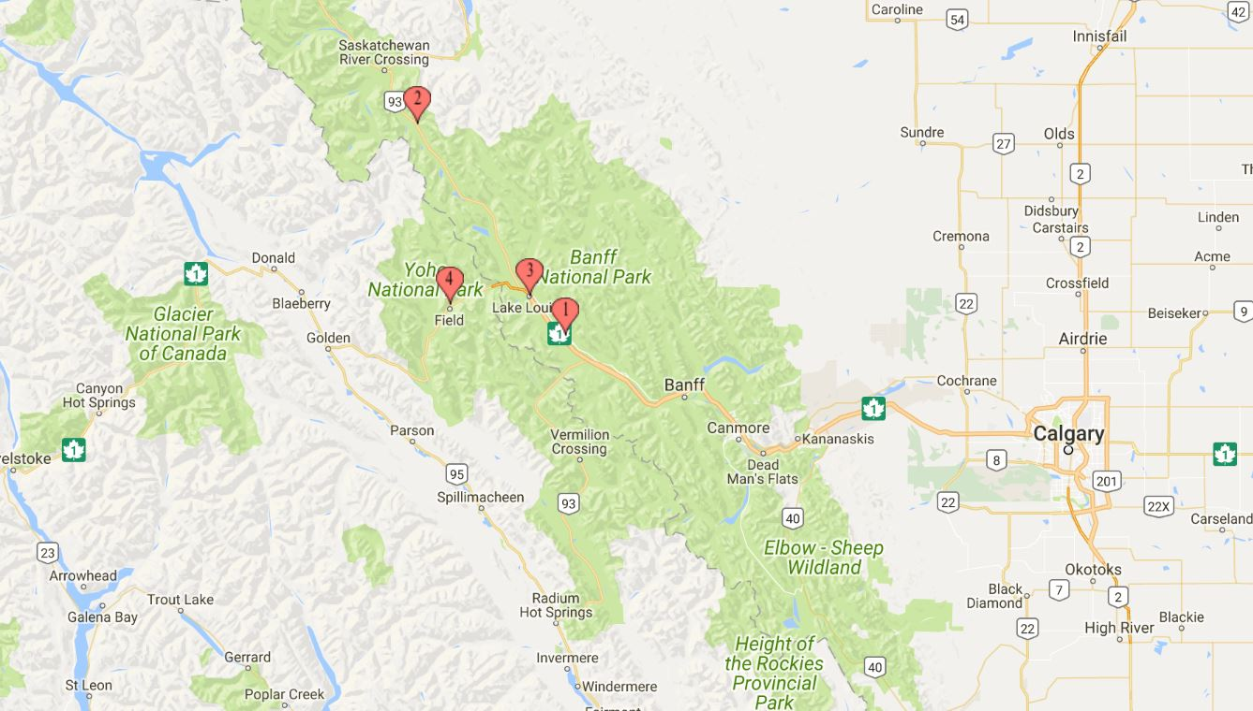
Manitoba
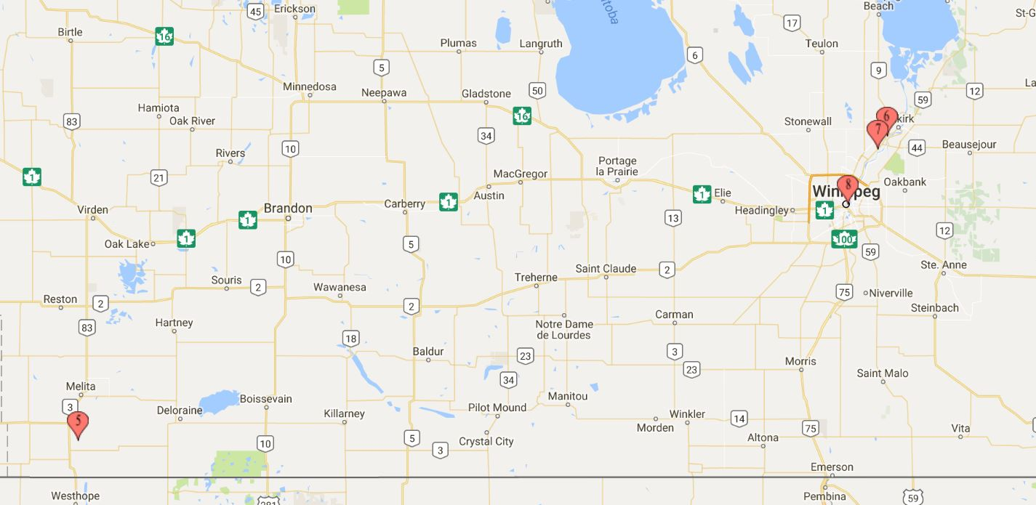

Ontario
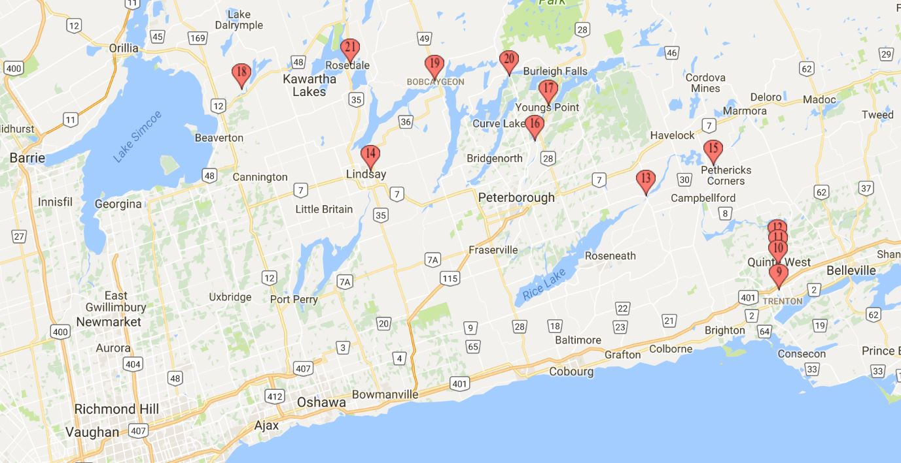

Ontario / Quebec
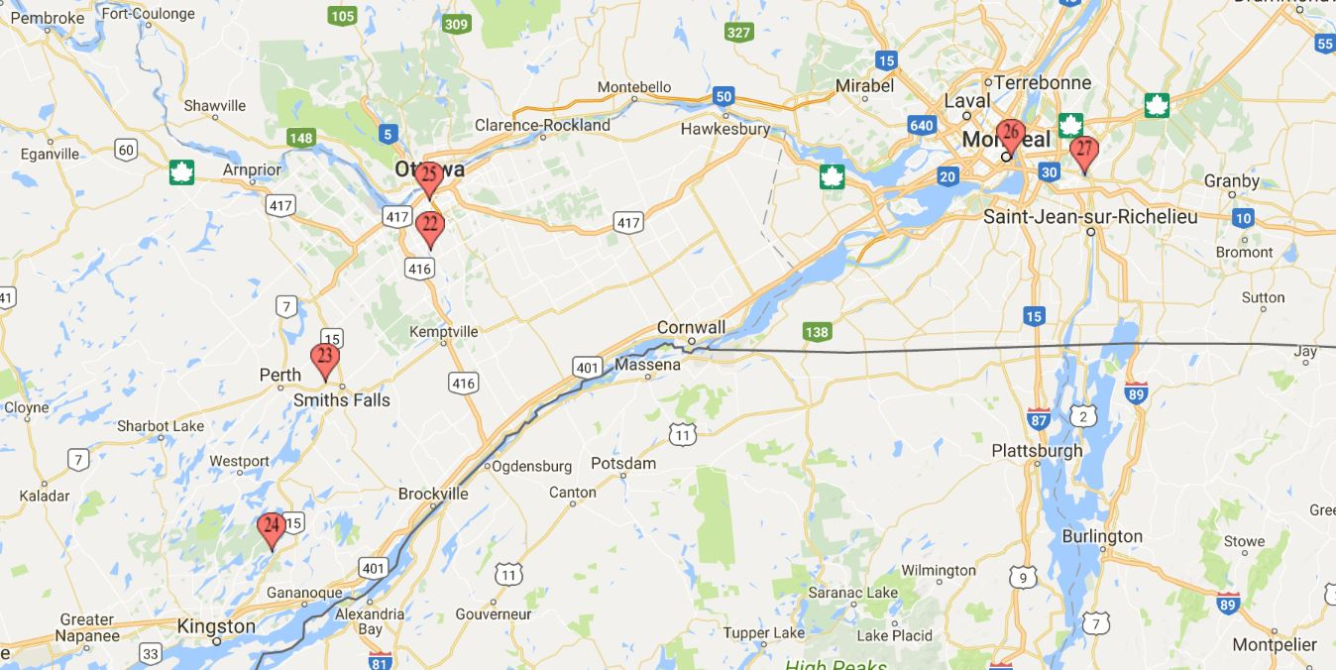

New Brunswick / Nova Scotia
Nouveau-Brunswick / Nouvelle-Écosse
