GENERAL
- Summary of the work
- Fabrication
  - The Contractor commits to build each module described in the provided set of plans, as per the instructions, to the best of his expertise.

- Installation
  - The Contractor will provide all materials, labour, tools, temporary protections, scaffolding, lifting systems, as well as all facilities and services required for full performance of the work described in the documents.

- Type of contract
- The work must be performed per a single, fixed-price contract based on all the contract documents.

- Work schedule
- The work must be performed in accordance with the construction schedule.

- Minimal standards and requirements
- Materials must be new and the work must comply with the minimal applicable standards of the Canadian General Standards Board (CGSB), the Canadian Standards Association (CSA), the Quebec Construction Code, the National Building Code of Canada 2005 (NBC) and all provincial and municipal applicable codes and regulations.
- The work must meet the standards and restrictions provided by the Owner.
- In case of divergence or contradiction, the strictest requirements will prevail.
- Subcontractors must commit to meet the same conditions as the General Contractor.

5. PROPOSALS OF SUBSTITUTIONS

1- No proposals of substitutions will be accepted during the bidding period.
2- The bidder cannot, and must not, under any circumstance, base the price of his submission on substitutes.
3- Any material, equipment, product or method that a contractor, a sub-contractor or a vendor wishes to propose as an equivalent to one of
those specified in the contract documents must first be submitted to the client for approval.
4- These substitution request must contain, at a minimum, the following information:
a. The reason for the substitution and the explanation of the benefit for the client to consider the proposed substitution.
b. The technical sheets for each product or the description of each system (specified and proposed) allowing a comparison of the proposal with the requirements of the contract documents.
c. A comparative table with full descriptive data for each of the products or systems (specified and
proposed) allowing a comparison of the substitution with the requirements of the contract documents.
d. The cost savings or increase associated with this substitution, including unit costs and quantities, and
a total amount (saved or increased).
e. Any additional information, sample or document the client might deem necessary.
5- Only the materials, equipment, products or systems accepted in writing by the client will be considered as valid substitutes.

- Protection measures
- The Contractor must limit his interventions on the job site to the minimum required.
- Protect neighbouring areas from dust and grime, which must be kept within the work area. Perform the work while disturbing as little as possible the normal operation of the premises. Make arrangements with the Owner to facilitate performance of the work.
- Maintain the buildings’ existing services and set up the necessary accesses for people and vehicles.

- General notes
- The Contractor must provide plans and specifications that meet the same performance criteria as those provided. The plans provided are for information only and in no way represent construction plans. Shop drawings should at a minimum represent each face of the different elements (non-exhaustive). Shop drawings must be approved by the client.
- The Contractor must ensure the stability of all elements (showcases, furniture, podiums, video screens, etc.).
- All structural elements (exhibition walls, furniture, etc.) must be proposed by the Contractor. Where necessary, approval of an engineer is required. The Contractor is responsible for the structural behaviour.
- Interior free space must be sufficient to allow technicians to move during maintenance.
- No screws or attachment system may be visible from the public side.
- Electrical power will come from floor boxes, hidden by exhibition elements or by the lighting rail on the ceiling.
- Final colour of the zones remains to be confirmed with the CMN.
- Openings in the exhibition walls must be CNC-cut.
- Final position of all the elements remains to be coordinated with the CMN.
- Graphical design is not represented in the set of plans. Final position must be coordinated with the CMN.

  - Mock-ups and samples (see annex A)
- One wall section showing :
  - at least one full removable panel;
  - the baseboard at the bottom of the panel;
  - the horizontal and vertical jointing principle;
  - the door’s frontal access principle;
  - a typical M2 metal insert (raw steel with a coat of transparent varnish).
- One complete showcase (plywood wall, black box, support, access, lighting, etc.). “Type A” proposal. SH-Z03-01.
- One section of podium showing the base, including the glass system and stage floor.
- One wall section with mirror (Sustainability) which must show the principle of the trapdoor to access the artifacts, the lighting and the reflection of the artifact.
- All the different samples of the materials presented on page 1534-SC-ALL-000.
- The four sample wall panels (see points 7.2 and 7.3):
  - 3 × (800 × 600), solid colours, colours to be coordinated with the CMN ;
  - 1 × (1 585 × 600), gradient colours, colours to be coordinated with the CMN.
- Web section of the “ecosystem” area :
  - one cable with the attachment structure at each end, extending from the podium to the exhibition wall.

  - Staining of the exhibition walls
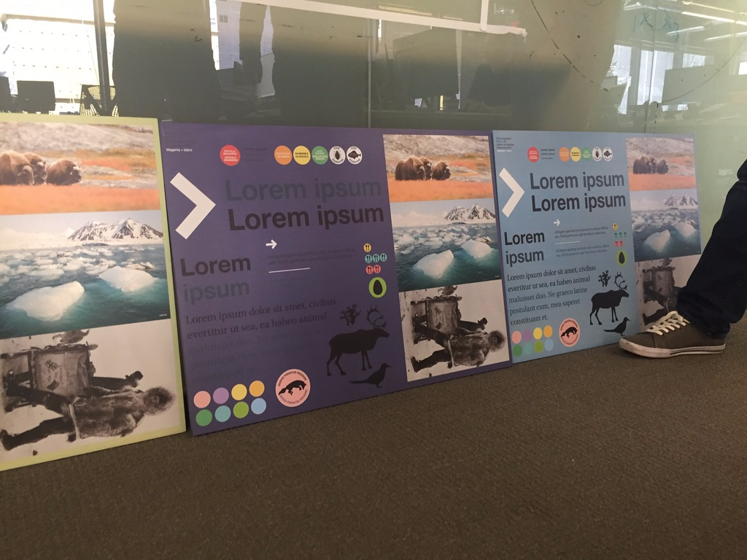
- Products:
  - Saman varnish ;
  - latex paints extender;
  - universal dyes.
- Tools:
  - Varnish brushes ;
  - sponge rollers.
- Application:
  - Lightly seal the wood before applying the colours.
  - Create the colour in a small quantity of varnish.
  - Extend with the varnish and a little extender (10%), until the desired transparency is reached. A small amount of water (1%) makes application easier.
  - For solid surfaces:
    - apply with a sponge roller.
  - For colour chromatics:
    - use the varnish brushes (4”) to apply the first coat of colours. Use a sponge roller for the successive coats. A nice colour gradient is done in several successive coats (4 or 5, even more).
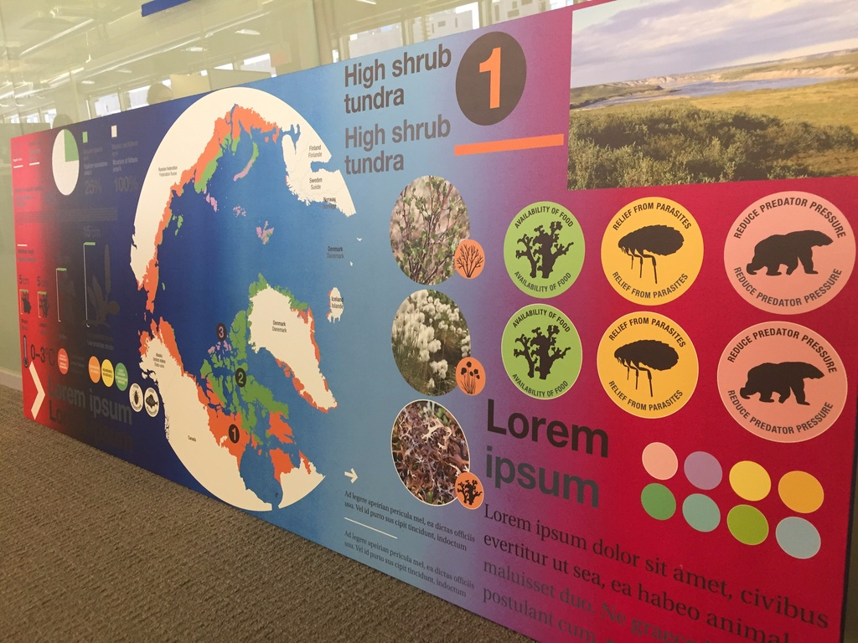

  - Printing on the exhibition walls
- All texts and graphics are printed directly on the stained plywood.
- The maximum curving tolerance of the panel must be 1.5 mm.
- The graphical design file must contain three layers:
  - 1st layer: the whole design in white;
  - 2nd layer: the colour representing true whites;
  - 3rd layer: all colours in CMYK.
- Printing process:
  - The 1st layer is printed twice in white.
  - The 2nd layer serves as reference for the whites. It is not printed.
  - The 3rd layer is printed once in CMYK.
  - The “scenography” Contractor applies a gloss coating to seal and protect the printing.

  - Audiovisual
- Specifications, dimensions and final integration of audiovisual elements are to be coordinated with the procurement list provided.
- Ensure proper ventilation of audiovisual equipment in keeping with the models chosen and taking into consideration the proposed installation systems.

  - Specimen podiums
- Specimens will be provided and installed by the CMN.
- Specimens must be parallel to the slope of their podium.
- The leg structure must be determined by the Contractor and coordinated with the CMN.
- The leg structured must be anchored to the floor.
- The glass is laminated and tempered, and its thickness is to be coordinated with the “showcase” Contractor and the CMN.
- The structure must use the exact same colour and process as the adjacent exhibition walls.

  - Fossil showcases
- The whole of the graphical designs, contents, and artifacts (non-exhaustive) must be coordinated with the CMN before validating the final dimensions of the different elements.
- Artifacts will be accessed by lifting the glass panel with suction cups.
- The glass making up the fossil showcases must be tempered, with the thickness and lamination to be validated with the “showcase” Contractor and the CMN.
- The artifacts’ conservation properties are to be coordinated between the Contractor and the CMN.
- The structure must use the exact same colour and process as the adjacent exhibition walls.
- Lighting will be adjusted by the person in charge of lighting.

  - Herbaria
- The whole of the graphical designs, contents, and artifacts (non-exhaustive) must be coordinated with the CMN before validating the final dimensions of the different elements.
- Artifacts will be accessed by lifting the glass panel with suction cups.
- The glass making up the herbaria must be tempered, with the thickness and lamination to be validated with the “showcase” Contractor and the CMN.
- The artifacts’ conservation properties are to be coordinated between the Contractor and the CMN.
- The structure must use the exact same colour and process as the adjacent exhibition walls.
- Lighting will be adjusted by the person in charge of lighting.

  - Showcases
- The artifacts’ conservation properties are to be coordinated between the Contractor and the CMN.
- The glass making up the showcases must be tempered, with the thickness and lamination to be validated with the “showcase” Contractor and the CMN.
- All showcases are to be equipped with a silica gel compartment.
- Lighting will be adjusted by the person in charge of lighting.
- All showcases will have rear or side access, unless otherwise specified.
- Showcase access is to be determined between the “scenography” Contractor, the “showcase” Contractor and the CMN.
- Only the following showcases have “front” access:
  - SH-Z03-01 ;
  - SH-Z03-02 ;
  - SH-Z05-02.

- Regarding the above showcases:
  - The concept is to move the panel with the showcase, at once, on a freestanding structure equipped with low profile casters, to move it forward and gain access to the rear of the showcase. After maintenance, a guide is used to insert the panel back in its original position.
  - Technical specifications for the casters will be determined by the total weight of the freestanding structure and the showcase.

  - Z02-Anchor
- Benches must be anchored to the floor.
- Painting of the anamorphic image must be done in place.
- A varnish must be applied in place after the painting work.
- The CMN must provide the anamorphic image model.

  - Z03-Geography
- Arctic map projection screen
  - The projection screen type is to be determined between the audiovisual Contractor and the CMN.
  - The position and type of video projector are to be determined between the audiovisual Contractor and the CMN.
  - The hanging systems are to be validated by an engineer.
  - The position of the fire sprinklers is to be taken into consideration.

  - Z04-Climate
- The snowmobile is provided by the CMN.
- The freezer is provided by the CMN.

  - Z05-Sustainability
- Touchables
  - Touchable artifacts or objects are glued to the counter surface. To be coordinated with the CMN.

  - Z06-Ecosystems
- Aquariums
  - The aquariums are provided by the CMN and must be coordinated with the CMN and a structural engineer for maximum loads.
  - Aquariums are accessed from the rear.
  - Neoprene strips must protect the sections of glass which are in contact with the structure.
  - Lighting adjustment and performance requirements are borne by the person in charge of lighting.
- Web
  - The Contractor must ensure the stability of all cables.
  - The supports are to be determined by the Contractor, with the approval of an engineer if necessary.
  - All junctions (cable/cable ; cable/element ; etc.) must be angled and perfectly finished.
  - Final position of the cables must be approved by GSM Project.
  - Cable type and diameters are to be determined by the “scenography” Contractor with the approval of the CMN.
  - The “scenography” Contractor must provide a sampling of blue sheathing to cover the cables.
  - Final sheathing selection is to be coordinated between GSM, the CMN and the “scenography” Contractor.

ANNEX A – Mock-ups plans

